http://www.comenius.org.pl/sites/www.comenius.org.pl/themes/comenius/images/logo_llp.png

**Programme of the visit in Poland**

**23-28.09.2013**

**23 September (Monday)**

Arrival of Bulgarian, Czech and Spanish group

**24 September (Tuesday)**

9.00 – 10.30 Meeting at school, official welcome

10.30 – 13.00

* Presenting brochure and film “How to play safely”
* Presentation of the family games prepared by all participants

13.00 – 13.40 Lunch break

13.40 – 15.30

* Demonstration of outdoor team games (all participants)
* Outdoor games competition

15.30 - 16.00 Teachers’ meeting, coffee time

**25 September (Wednesday)**

9.15 – Meeting at the market square

9.30 – 10.00 Visiting the Town Hall, meeting with the mayor of Pszczyna

10.00 – 12.00 Visiting the Pszczyna Castle, walk in the park, visiting Bison Yard

12.00 – 14.00 Trip to the Water Sports Centre in Łąka (sailing boats and water bikes)

14.00 – 15.00 Lunch break – barbecue

15.00 - 17.00 Trip to the Horse Recreation Centre (kids and teachers will have the opportunity to ride horses)

**26 September (Thursday)**

8.00 Departure from Pszczyna

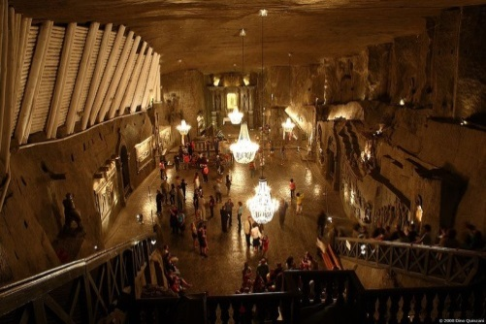10.00 – 12.00 Visiting Wieliczka Salt Mine – the only salt mine in the world preserved in such pristine condition and placed on the UNESCO list of the World Heritage Sites.

12.00 Departure to Cracow

13.00 – 14.00 Lunch at the restaurant in the main market square

14.00 – 16.00 Sightseeing Cracow – the Old Town, Mariacki Church, visiting Wawel Castle and Wawel dragon, walk along Vistula river

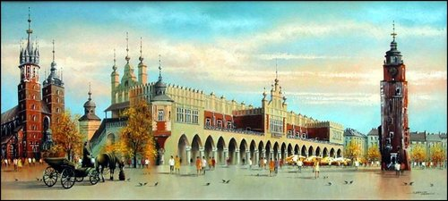16.00 – 17.00 Free time

18.00 – Departure to Pszczyna

**27 September (Friday)**

8.00 Trip to the mountains

9.00 – 14.00 Hiking

14.00 – 15.00 Lunch break

15.00 – Departure to Pszczyna

16.00 – 18.00 Free time for students and teachers

18.30 Certificate ceremony and farewell party with lots of surprises☺

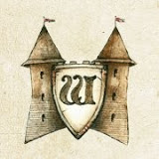

**28 September (Saturday)**

Departure of all participants

Note: The temperature in the Salt Mine ranges between 14° and 16°C so make sure you take warmer clothes with you. When preparing for your visit, please remember to wear comfortable shoes.